- Visualizing Amounts and Distributions
Data set:
df <- data.frame(
Date = as.Date(c(
"2024-01-01","2024-02-01","2024-03-01",
"2024-04-01","2024-05-01","2024-06-01",
"2024-07-01","2024-08-01","2024-09-01",
"2024-10-01","2024-11-01","2024-12-01"
)),
Sales = c(120, 135, 150, 165, 180, 200, 220, 240, 260, 280, 300, 320)
)

# Add Month and Quarter columns
df$Month <- format(df$Date, "%b")
df$Quarter <- paste0("Q", ceiling(as.numeric(format(df$Date, "%m")) / 3))

# View dataset
df
1
ggplot(df, aes(x = Date, y = Sales, fill = Month)) +
geom_bar(stat = "identity") +
ggtitle("Bar Plot - Monthly Sales") +
xlab("Date") +
ylab("Sales")
output:
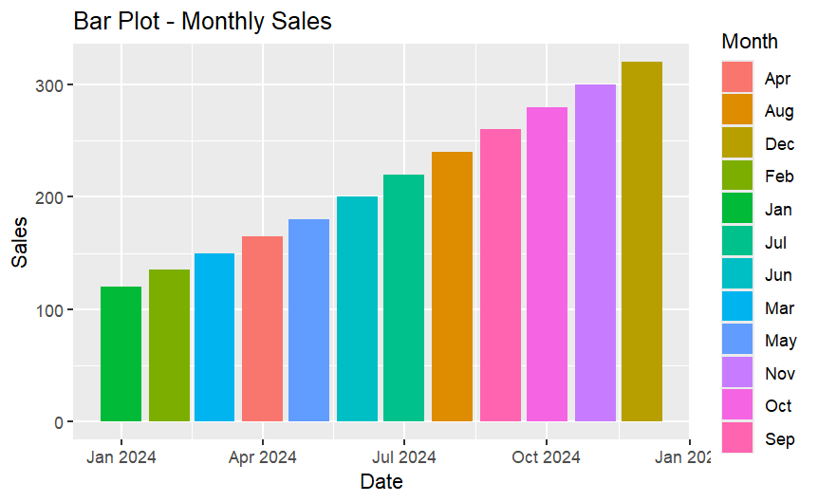
2
ggplot(df, aes(x = Quarter, y = Sales, fill = Month)) +
geom_bar(stat = "identity", position = "dodge") +
ggtitle("Grouped Bar Plot - Sales by Quarter & Month") +
xlab("Quarter") +
ylab("Sales")
output:
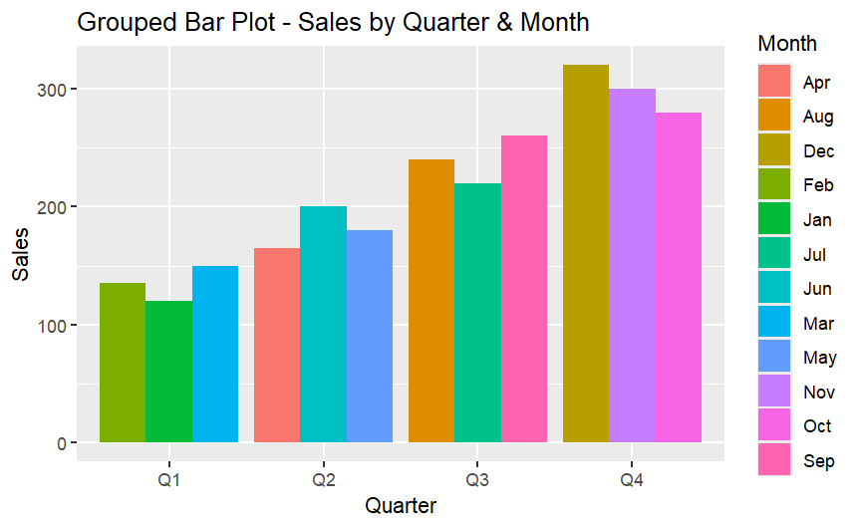
3
ggplot(df, aes(x = Quarter, y = Sales, fill = Month)) +
geom_bar(stat = "identity") +
ggtitle("Stacked Bar Plot - Sales by Quarter & Month") +
xlab("Quarter") +
ylab("Sales")
output:
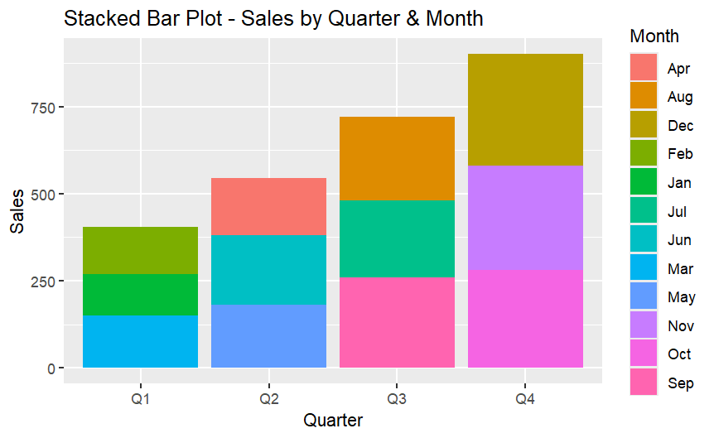
4
ggplot(df, aes(x = Quarter, y = Sales, color = Quarter)) +
geom_point(size = 3) +
ggtitle("Dot Plot - Sales by Quarter") +
xlab("Quarter") +
ylab("Sales")
output:
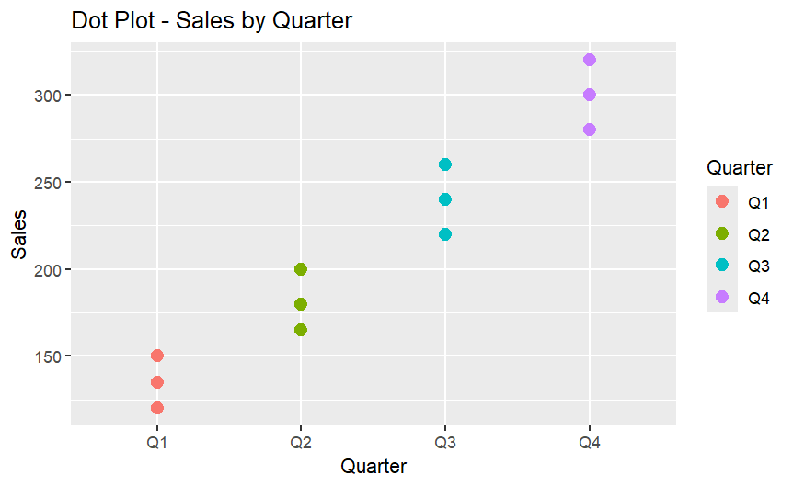
5
ggplot(df, aes(x = Quarter, y = Sales, fill = Quarter)) +
geom_violin(color = "black") +
ggtitle("Violin Plot - Sales Distribution by Quarter") +
xlab("Quarter") +
ylab("Sales")
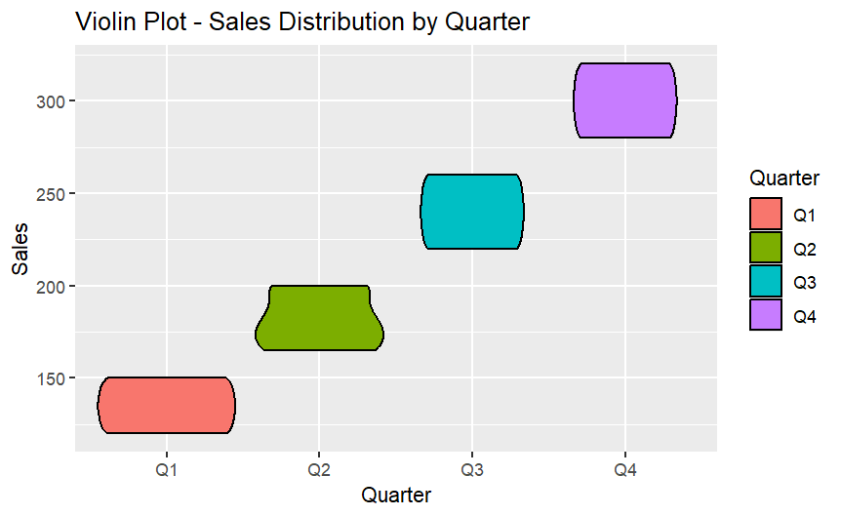

6
library(ggridges)
ggplot(df, aes(x = Sales, y = Quarter, fill = Quarter)) +
geom_density_ridges(alpha = 0.7) +
ggtitle("Ridgeline Plot - Sales Distribution by Quarter") +
xlab("Sales") +
ylab("Quarter")
OUTPUT:
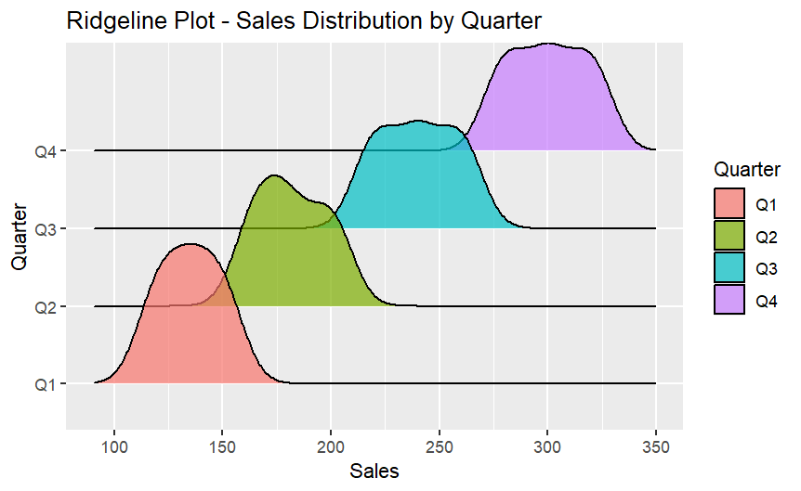
7
ggplot(df, aes(x = Date, y = Sales)) +
geom_line(color = "blue", linewidth = 1.2) +
geom_point(color = "red", size = 3) +
ggtitle("Line Plot - Monthly Sales") +
xlab("Date") +
ylab("Sales")
OUTPUT:
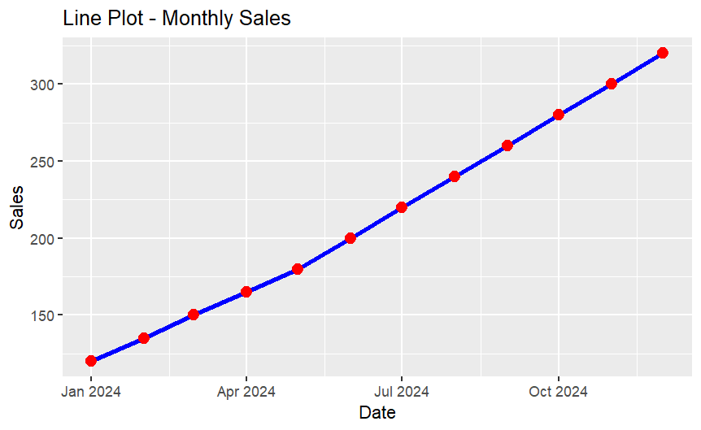
8
ggplot(df, aes(x = Sales, fill = factor(..count..))) +
geom_histogram(binwidth = 20, color = "black") +
ggtitle("Histogram - Sales Distribution") +
xlab("Sales") +
ylab("Frequency") +
guides(fill = "none")
OUTPUT:
9
ggplot(df, aes(x = Sales)) +
geom_density(color = "blue", linewidth = 1.2) +
ggtitle("Density Plot - Sales") +
xlab("Sales") +
ylab("Density")
OUTPUT:
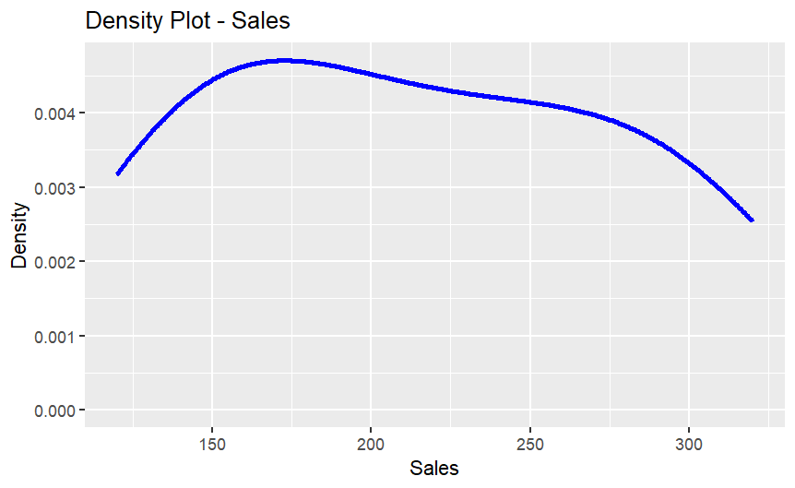
10
ggplot(df, aes(y = Sales)) +
geom_boxplot(
fill = "lightpink",
color = "black",
width = 0.4
) +
ggtitle("Box Plot - Sales") +
ylab("Sales")
OUTPUT:
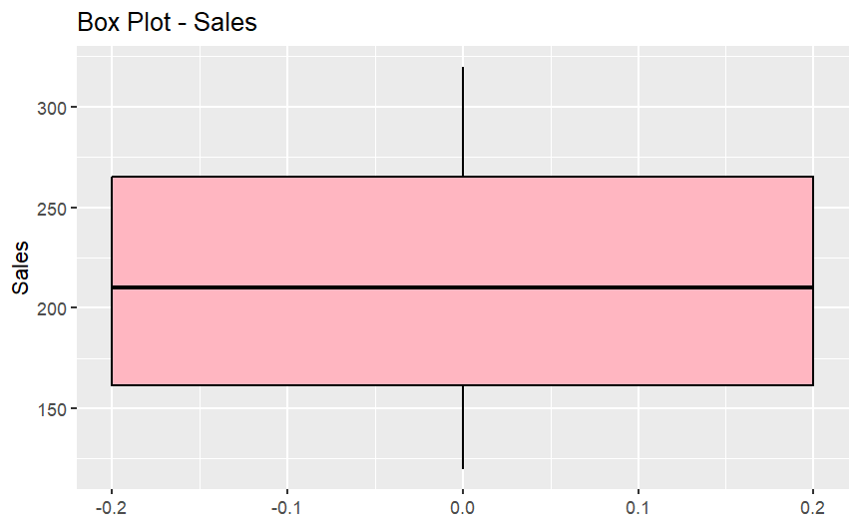

2. Visualizing Proportions

Data set:
df <- data.frame(
Category = c("Food", "Food", "Clothing", "Clothing", "Electronics", "Electronics"),
Subcategory = c("Fruits", "Snacks", "Men", "Women", "Mobile", "Laptop"),
Value = c(40, 20, 30, 10, 50, 25)
)
1.
library(ggplot2)
ggplot(df, aes(x = "", y = Value, fill = Category)) +
geom_bar(stat = "identity") +
coord_polar("y") +
ggtitle("Pie Chart - Category Proportions")
output:
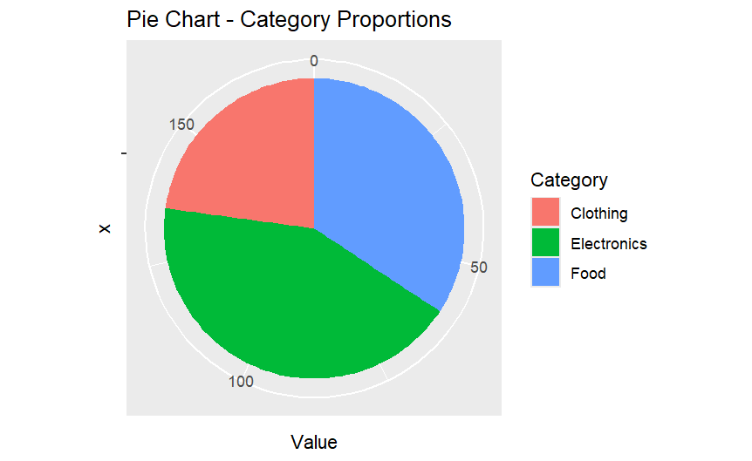
2
ggplot(df, aes(x = Category, y = Value, fill = Subcategory)) +
geom_bar(stat = "identity") +
ggtitle("Stacked Bar Plot - Category and Subcategory Proportions") +
xlab("Category") +
ylab("Value")

output:
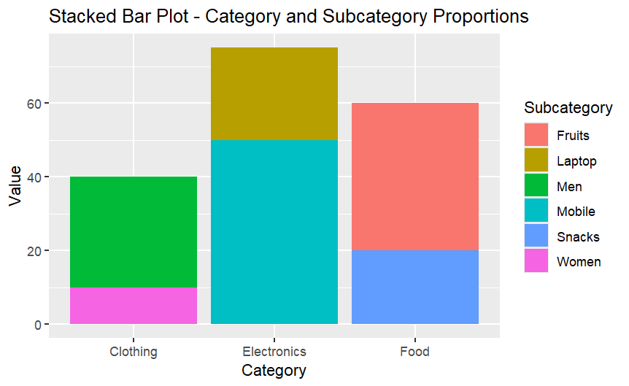
3
library(treemapify)
ggplot(df, aes(area = Value, fill = Category, label = Subcategory)) +
geom_treemap() +
geom_treemap_text(colour = "white", place = "centre") +
ggtitle("Treemap - Hierarchical Proportions")
output:
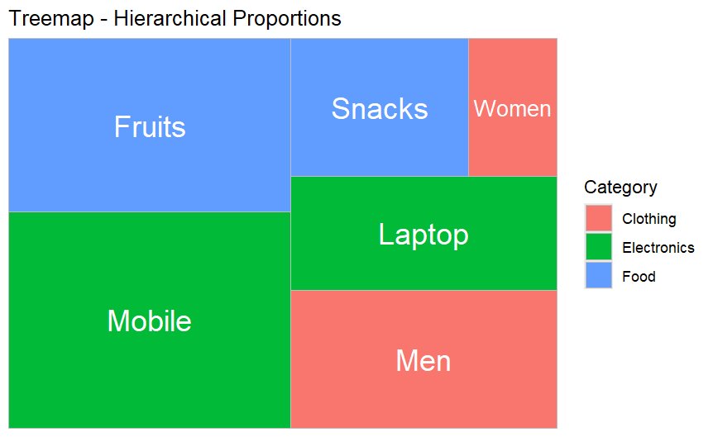
4
library(sunburstR)
sunburst_df <- data.frame(
sequence = paste(df$Category, df$Subcategory, sep = "-"),
count = df$Value
)
sunburst(sunburst_df)
output:
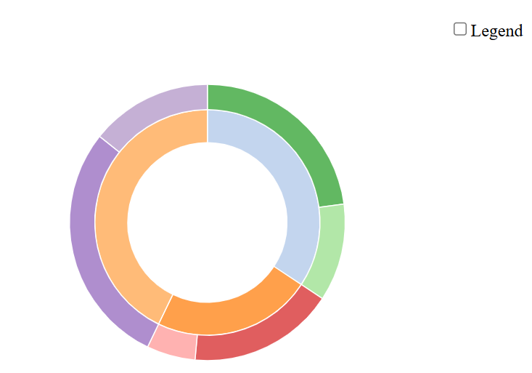
5
library(ggalluvial)
library(ggplot2)
ggplot(df,
aes(axis1 = Category,
axis2 = Subcategory,
y = Value)) +
geom_alluvium(aes(fill = Category)) +
geom_stratum(aes(fill = Category)) +
geom_text(stat = "stratum",
aes(label = after_stat(stratum)),
color = "black") +
ggtitle("Parallel Sets - Category to Subcategory (Colored)")
output:
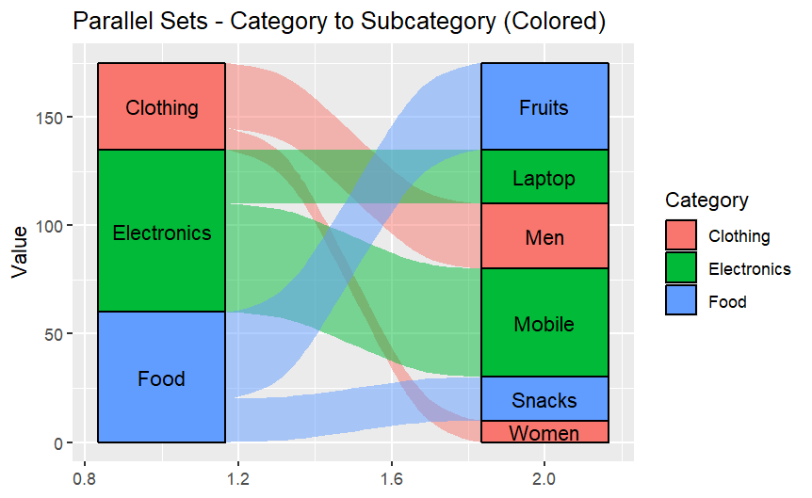
6
library(networkD3)
nodes <- data.frame(
name = c("Food", "Clothing", "Electronics",
"Fruits", "Snacks", "Men", "Women", "Mobile", "Laptop")
)

links <- data.frame(
source = c(0, 0, 1, 1, 2, 2),
target = c(3, 4, 5, 6, 7, 8),
value = c(40, 20, 30, 10, 50, 25)
)

sankeyNetwork(
Links = links,
Nodes = nodes,
Source = "source",
Target = "target",
Value = "value",
NodeID = "name"
)
Output:
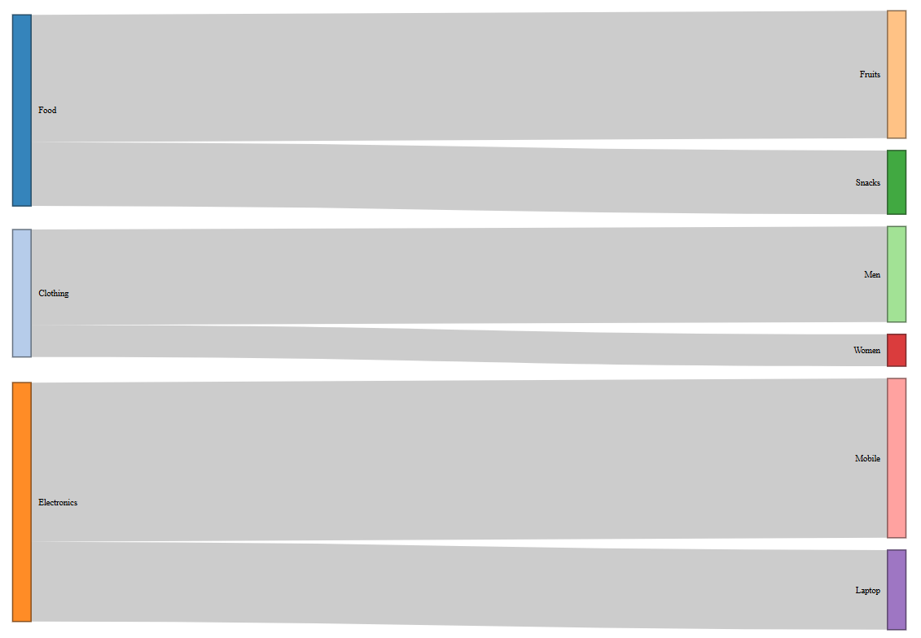
3. Visualizing Relationships and Associations

Data set:
df <- data.frame(
X = c(10, 20, 30, 40, 50, 60),
Y = c(15, 25, 35, 45, 55, 65),
Z = c(5, 10, 15, 20, 25, 30)
)
df <- data.frame(
X = c(10, 20, 30, 40, 50, 60),
Y = c(18, 22, 37, 41, 53, 60),
Z = c(5, 15, 10, 25, 20, 30)
)
1
ggplot(df, aes(x = X, y = Y)) +
geom_point(color = "blue", size = 3) +
ggtitle("Scatter Plot - Relationship between X and Y")
output:
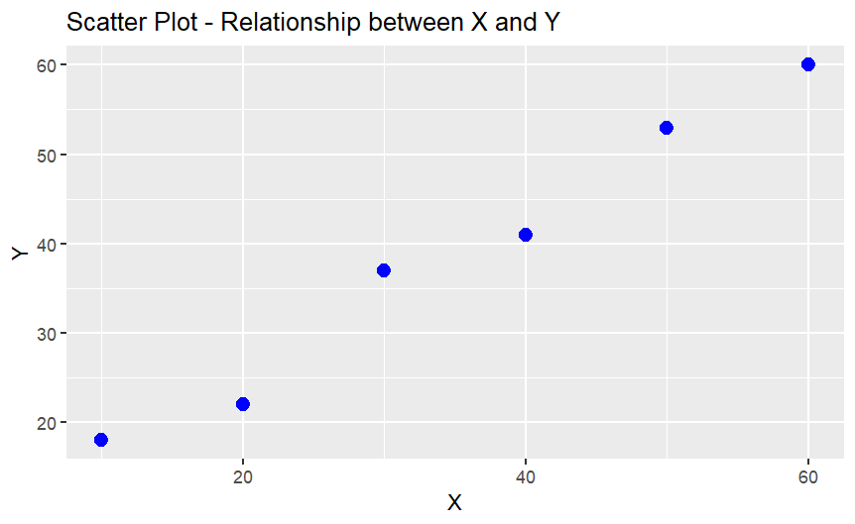
2
ggplot(df, aes(x = X, y = Y, size = Z)) +
geom_point(alpha = 0.6, color = "red") +
ggtitle("Bubble Chart - X vs Y with Size Z")
output:
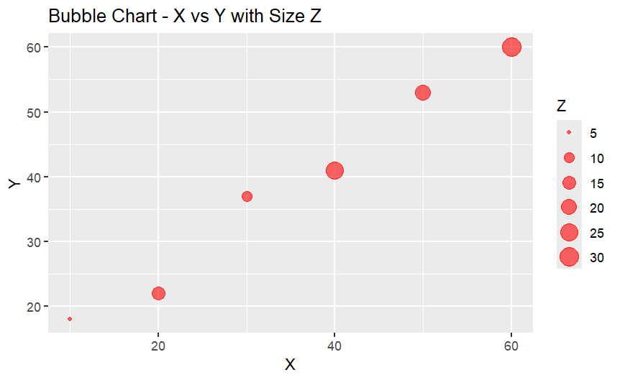
3
library(hexbin)
ggplot(df, aes(x = X, y = Y)) +
geom_hex() +
ggtitle("Hexbin Plot - Density Visualization")
output:
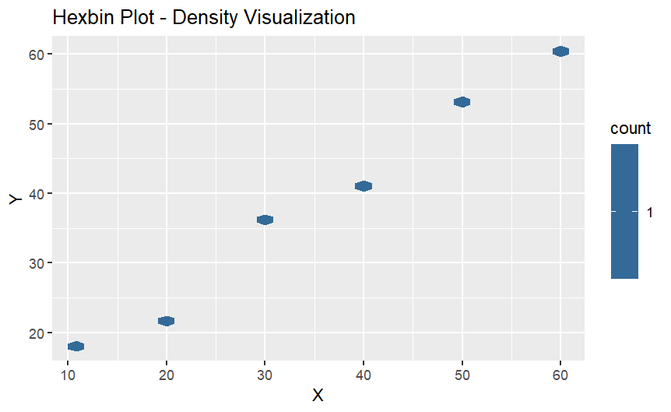
4
library(corrplot)
corrplot(
cor(df),
main = "Correlogram - Correlation Between Variables"
)
Output:
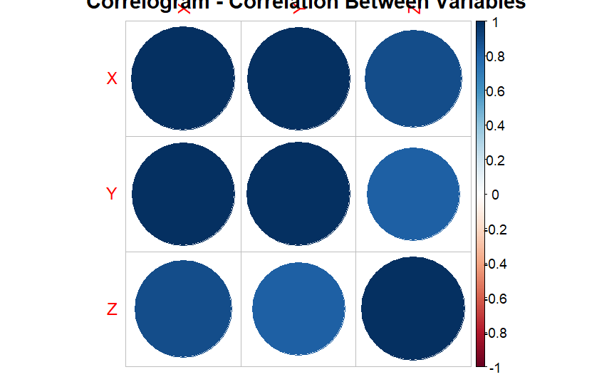

5
V(graph)$color <- c("red", "green", "blue", "orange")
plot(graph,
vertex.size = 30,
vertex.label.color = "black",
main = "Colored Network Graph")
output:
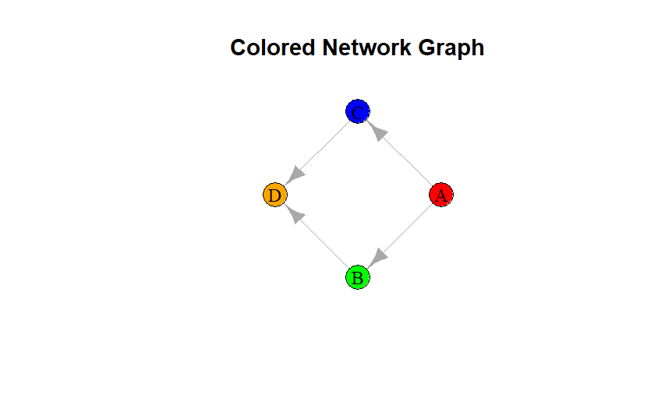
6
library(ggfortify)
autoplot(
prcomp(df, scale. = TRUE),
data = df,
colour = "Z",
size = 3
) +
ggtitle("PCA Plot - Dimensionality Reduction Visualization")
output:
